SEC Form 3
FORM 3 | UNITED STATES SECURITIES AND EXCHANGE COMMISSION  Washington, D.C. 20549  INITIAL STATEMENT OF BENEFICIAL OWNERSHIP OF SECURITIES  Filed pursuant to Section 16(a) of the Securities Exchange Act of 1934  or Section 30(h) of the Investment Company Act of 1940
  OMB APPROVAL
  OMB Number: | 3235-0104
  Estimated average burden
  hours per response: | 0.5
1. Name and Address of Reporting Person*  (Street) | 2. Date of Event Requiring Statement (Month/Day/Year)  08/17/2026 | 3. Issuer Name and Ticker or Trading Symbol  Latham Group, Inc. [ SWIM ]  Foreign Trading Symbol
  Antonelli Todd A
  (Last) | (First) | (Middle)
  C/O LATHAM GROUP, INC.
  787 WATERVLIET SHAKER ROAD
  LATHAM | NY | 12110
  (City) | (State) | (Zip)
 |  | 4. Relationship of Reporting Person(s) to Issuer  (Check all applicable) | 5. If Amendment, Date of Original Filed (Month/Day/Year)
   | Director |  | 10% Owner
   | Officer (give title below) |  | Other (specify below)
  Chief Commercial Officer
6. Individual or Joint/Group Filing (Check Applicable Line)
Form filed by One Reporting Person
Form filed by More than One Reporting Person

Table I - Non-Derivative Securities Beneficially Owned
1. Title of Security (Instr. 4) | 2. Amount of Securities Beneficially Owned (Instr. 4) | 3. Ownership Form: Direct (D) or Indirect (I) (Instr. 5) | 4. Nature of Indirect Beneficial Ownership (Instr. 5)
Table II - Derivative Securities Beneficially Owned
(e.g., puts, calls, warrants, options, convertible securities)
1. Title of Derivative Security (Instr. 4) | 2. Date Exercisable and Expiration Date (Month/Day/Year) |  | 3. Title and Amount of Securities Underlying Derivative Security (Instr. 4) |  | 4. Conversion or Exercise Price of Derivative Security | 5. Ownership Form: Direct (D) or Indirect (I) (Instr. 5) | 6. Nature of Indirect Beneficial Ownership (Instr. 5)
1. Title of Derivative Security (Instr. 4) | Date Exercisable | Expiration Date | Title | Amount or Number of Shares | 4. Conversion or Exercise Price of Derivative Security | 5. Ownership Form: Direct (D) or Indirect (I) (Instr. 5) | 6. Nature of Indirect Beneficial Ownership (Instr. 5)
Explanation of Responses:
Remarks:
See Exhibit 24 - Todd A. Antonelli Power of Attorney
No securities are beneficially owned.
 | /s/ Patrick M. Sheller, Attorney-in-Fact | 08/17/2026
 | ** Signature of Reporting Person | Date
Reminder: Report on a separate line for each class of securities beneficially owned directly or indirectly.
* If the form is filed by more than one reporting person, see Instruction 5 (b)(v).
** Intentional misstatements or omissions of facts constitute Federal Criminal Violations See 18 U.S.C. 1001 and 15 U.S.C. 78ff(a).
Note: File three copies of this Form, one of which must be manually signed. If space is insufficient, see Instruction 6 for procedure.
Persons who respond to the collection of information contained in this form are not required to respond unless the form displays a currently valid OMB Number.
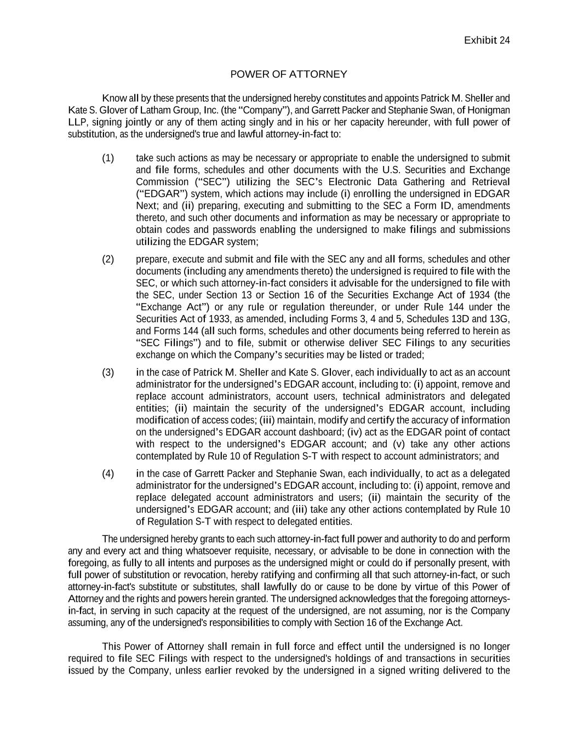
Exhibit 24 POWER OF ATTORNEY Know all by these presents that the undersigned hereby constitutes and appoints Patrick M. Sheller and Kate S. Glover of Latham Group, Inc. (the “Company”), and Garrett Packer and Stephanie Swan, of Honigman LLP, signing jointly or any of them acting singly and in his or her capacity hereunder, with full power of substitution, as the undersigned's true and lawful attorney-in-fact to: (1) take such actions as may be necessary or appropriate to enable the undersigned to submit and file forms, schedules and other documents with the U.S. Securities and Exchange Commission (“SEC”) utilizing the SEC’s Electronic Data Gathering and Retrieval (“EDGAR”) system, which actions may include (i) enrolling the undersigned in EDGAR Next; and (ii) preparing, executing and submitting to the SEC a Form ID, amendments thereto, and such other documents and information as may be necessary or appropriate to obtain codes and passwords enabling the undersigned to make filings and submissions utilizing the EDGAR system; (2) prepare, execute and submit and file with the SEC any and all forms, schedules and other documents (including any amendments thereto) the undersigned is required to file with the SEC, or which such attorney-in-fact considers it advisable for the undersigned to file with the SEC, under Section 13 or Section 16 of the Securities Exchange Act of 1934 (the “Exchange Act”) or any rule or regulation thereunder, or under Rule 144 under the Securities Act of 1933, as amended, including Forms 3, 4 and 5, Schedules 13D and 13G, and Forms 144 (all such forms, schedules and other documents being referred to herein as “SEC Filings”) and to file, submit or otherwise deliver SEC Filings to any securities exchange on which the Company’s securities may be listed or traded; (3) in the case of Patrick M. Sheller and Kate S. Glover, each individually to act as an account administrator for the undersigned’s EDGAR account, including to: (i) appoint, remove and replace account administrators, account users, technical administrators and delegated entities; (ii) maintain the security of the undersigned’s EDGAR account, including modification of access codes; (iii) maintain, modify and certify the accuracy of information on the undersigned’s EDGAR account dashboard; (iv) act as the EDGAR point of contact with respect to the undersigned’s EDGAR account; and (v) take any other actions contemplated by Rule 10 of Regulation S-T with respect to account administrators; and (4) in the case of Garrett Packer and Stephanie Swan, each individually, to act as a delegated administrator for the undersigned’s EDGAR account, including to: (i) appoint, remove and replace delegated account administrators and users; (ii) maintain the security of the undersigned’s EDGAR account; and (iii) take any other actions contemplated by Rule 10 of Regulation S-T with respect to delegated entities. The undersigned hereby grants to each such attorney-in-fact full power and authority to do and perform any and every act and thing whatsoever requisite, necessary, or advisable to be done in connection with the foregoing, as fully to all intents and purposes as the undersigned might or could do if personally present, with full power of substitution or revocation, hereby ratifying and confirming all that such attorney-in-fact, or such attorney-in-fact's substitute or substitutes, shall lawfully do or cause to be done by virtue of this Power of Attorney and the rights and powers herein granted. The undersigned acknowledges that the foregoing attorneys- in-fact, in serving in such capacity at the request of the undersigned, are not assuming, nor is the Company assuming, any of the undersigned's responsibilities to comply with Section 16 of the Exchange Act. This Power of Attorney shall remain in full force and effect until the undersigned is no longer required to file SEC Filings with respect to the undersigned's holdings of and transactions in securities issued by the Company, unless earlier revoked by the undersigned in a signed writing delivered to the

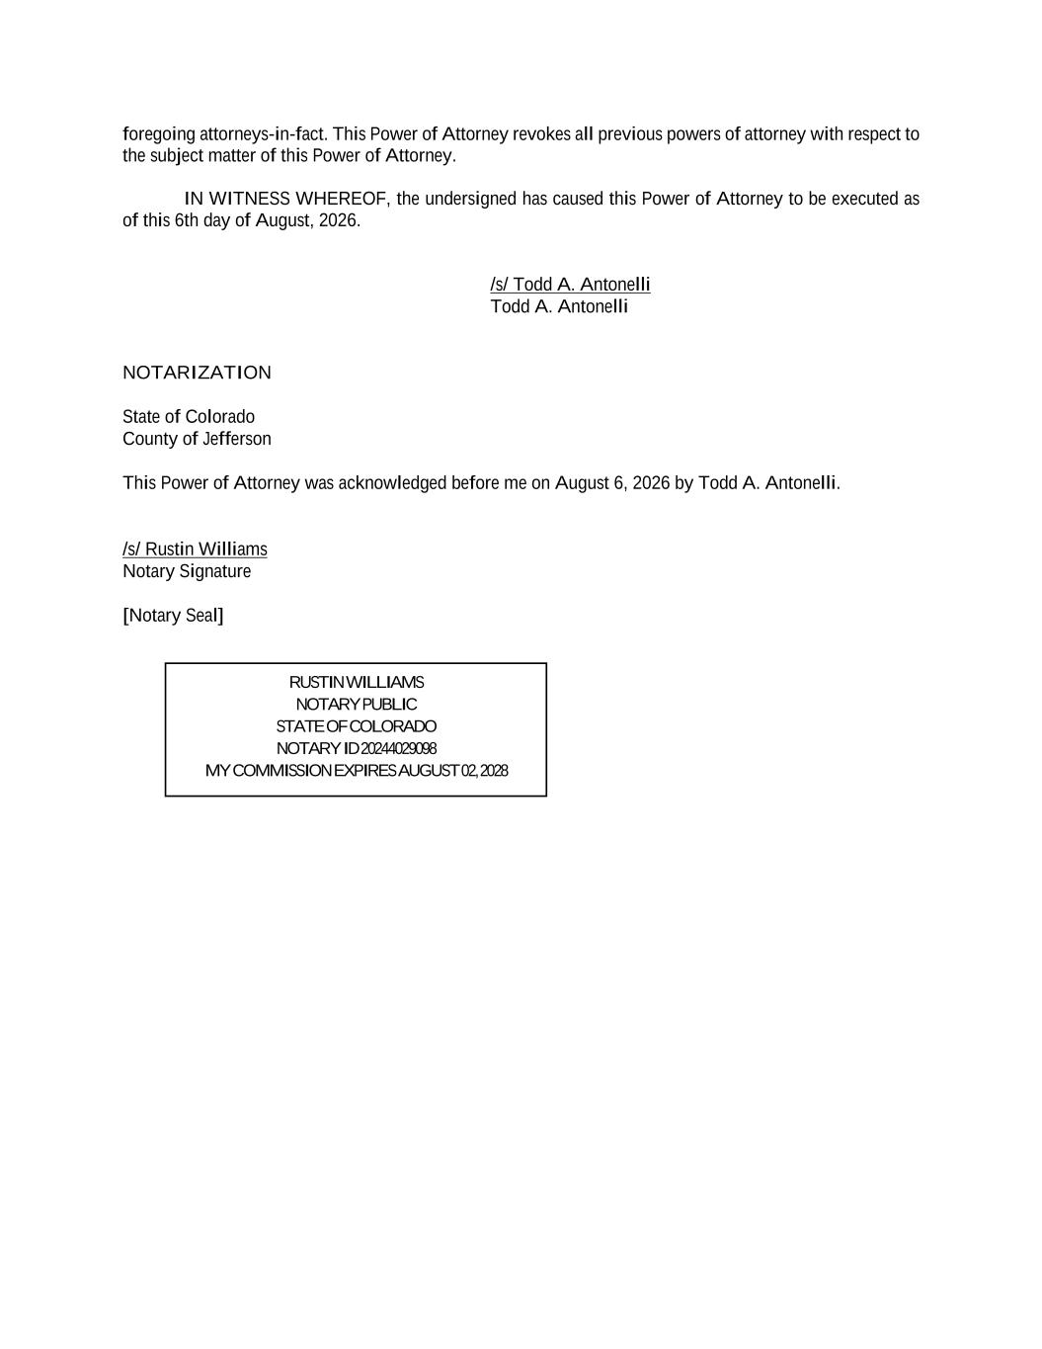
foregoing attorneys-in-fact. This Power of Attorney revokes all previous powers of attorney with respect to the subject matter of this Power of Attorney. IN WITNESS WHEREOF, the undersigned has caused this Power of Attorney to be executed as of this 6th day of August, 2026. /s/ Todd A. Antonelli Todd A. Antonelli NOTARIZATION State of Colorado County of Jefferson This Power of Attorney was acknowledged before me on August 6, 2026 by Todd A. Antonelli. /s/ Rustin Williams Notary Signature [Notary Seal] RUSTIN WILLIAMS NOTARY PUBLIC STATE OF COLORADO NOTARY ID 20244029098 MY COMMISSION EXPIRES AUGUST 02, 2028

